Assignment

# Facebook Data Set Analysis

The Problem statement is to predict how many comments a post on a Facebook Page is expected to receive in the 24 hours after a given base time.

The Training Data Set has 63,830 data points and 41 variables including the dependent variable. The Dependent variable has been labelled as – “PsC24”. Some of the other Independent variables include –

1. Page Popularity
2. Page Views
3. Category of the Page Source/ Document
4. Day on which the Post was Posted

## Preliminary Data Analysis/Data Visualisation

Firstly, the Distribution of the Dependent Variable (No. of Comments “PsC24”) is analysed through a Histogram and the result obtained is as follows:

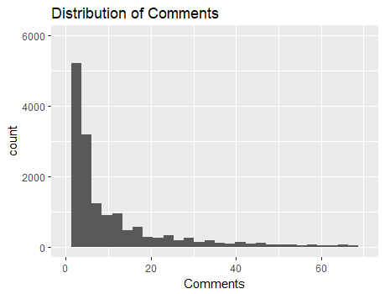

From the Histogram we can conclude that the Distribution of Comments is highly positively skewed as higher mass lies in the initial values and the tail is very long. Thus, clearly a high percentage of Posts receive very less Comments.

As the Comments can only take integer Values and the Distribution is clearly positively skewed thus it can be modelled using a Poisson Regression.

Next, the Distribution of Comments across different Categories is found out. The top 5 Categories in terms of comments is as follows:

1. Politician
2. Health/Medical/Pharmacy
3. TV Channel
4. Education Website
5. Actor/Director

Similarly the Categories having the lowest comments are as follows:

1. Cause
2. Sports/Recreation Activities
3. Home Décor
4. Undefined
5. Computers

So, clearly the Categories which have the highest comments are also intuitively likely to have high comments. As Politicians and actors have large masses of people following them thus likely to garner high number of comments.

The Frequency of Posts as per Days of Week:

1. Friday 7667
2. Monday 7567
3. Saturday 7132
4. Sunday 6226
5. Thursday 7567
6. Tuesday 7487
7. Wednesday 7418

Thus, clearly almost equal number of Posts has been posted on each day of the week. Thus, there is no particular day when the numbers of Posts were unusually high or low.

Next, the Distribution of Comments across each is visualised by a boxplot. The result is as follows:

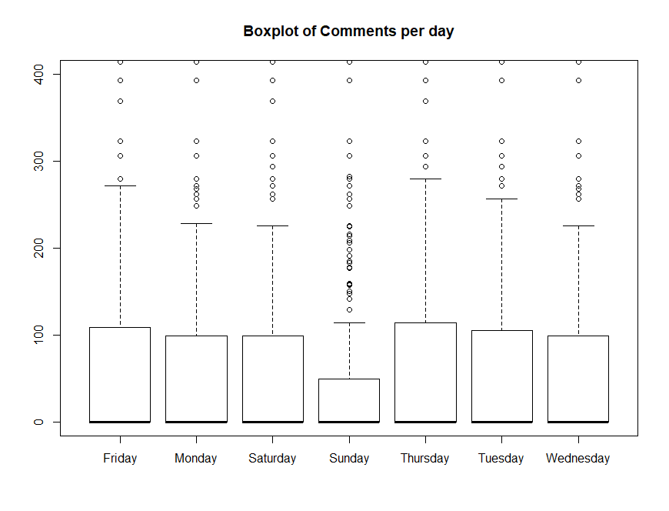

Thus, it is visible that Sunday has fewer comments overall as compared to other days. Even though the number of post on Sunday’s is not low even then the comments on posts posted on Sunday’s is clearly lesser.

## Data Cleaning and Manipulation

A summary of a few variables is as follows:

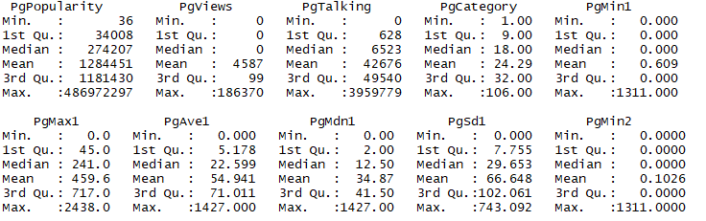

From above we can clearly see that the Maximum value and the Third Quantile for each variable are quite dispersed thus indicative of outlier values in the data set. Thus, for the modelling purpose we try to remove these extreme values.

For each Numeric variable we cut off rows where a particular variable’s value exceeds the 99th percentile.

## Model Training

The Data set was split into training and Validation data sets. The Model is fitted on the training data set and tested on the validation set.

After completing the Data Manipulation step several Models were fitted. The results are as follows:

### Regression Tree

A regression tree was fitted using the rpart package in R. The Diagrammatic representation of the tree is as follows:

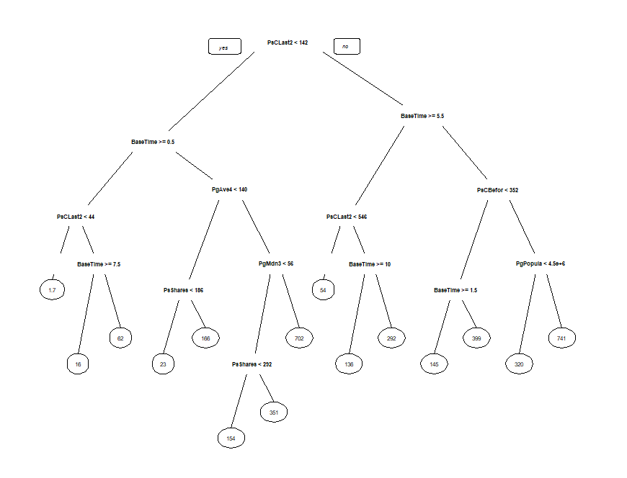

The Important Variables identified from the Decision tree are:

1. Page Popularity
2. Page Shares
3. Base Time
4. Number of posts before the base time

The Root Mean Squared Error value obtained from the Decision Tree for the Validation data set is : 26.25

The Plot for the Actual versus the Predicted value for the validation data set is as follows:

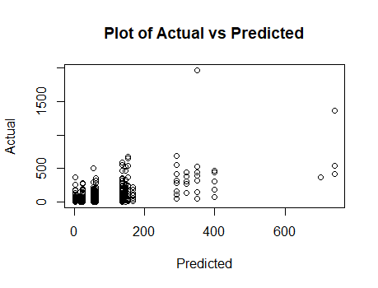

From the plot we can see that the model is not doing well for the Validation data set.

### Poisson Regression

As noted above that the distribution of comments was similar to that of the Poission Distribution thus we use the inbuilt “glm” function in R to fit a Poisson regression model.

The Root Mean Squared Error obtained on the Validation data set is 2619 which is much higher than the Decision tree Model. Thus, the Poisson Regression model is clearly not a good fit.

### LASSO

The Lasso model was fitted to the data. The model significantly reduces the dimension of the data. Hence, the final model obtained is:

(Intercept) 5.423825960

PgAve1 0.005462312

PgMdn2 0.314267880

PsCLast24 0.157943220

PsCDiff 0.020810141

BaseTime -0.122112525

PsShares 0.001307933

The Root mean squared obtained for the LASSO model is 31.32 for the validation. However, it is still lower than the Decision tree model.

### Linear Regression

The Linear Regression using stepwise regression was performed and the final model obtained was:

PsC24 ~ PgPopularity + PgViews + PgTalking + PgCategory + PgMax1 +

PgAve1 + PgMdn1 + PgSd1 + PgMin2 + PgMax2 + PgAve2 + PgMdn2 +

PgSd2 + PgMax3 + PgAve3 + PgMdn3 + PgSd3 + PgMin4 + PgMax4 +

PgAve4 + PgMdn4 + PgSd4 + PgMin5 + PgMax5 + PgMdn5 + PgSd5 +

PsCBefore + PsCLast24 + PsCLast48.24 + PsCFirst24 + BaseTime +

PsShares

The problem with a Linear Regression Model is that the predicted values can also be negative thus the predicted values were taken to be max{0, $\overbrace{y}$}, where $\overbrace{y}$ is the predicted value. Hence, this ensures that negative values are not taken.

The Root mean squared Error for the Linear Regression model is 1.01.

Hence, the Linear Regression model performs the best and it is used to generate predicted values of comments for the testing data set as well.

# Spam Data Set Analysis

The Problem statement is to predict whether an E-mail received is a Spam or not.

The Training Data Set has 3680 data points and 58 variables including the dependent variable. The Dependent variable has been labelled as – “spam”. Some of the other Independent variables include:

1. Percentage of a particular word occurring in the E-mail
2. Uninterrupted sequences of capital letters
3. Percentage of signs occurring in the email.

## Preliminary Data Analysis/Data Visualisation

Firstly, the Distribution of the Dependent Variable is analysed through a Bar Plot and the result obtained is as follows:

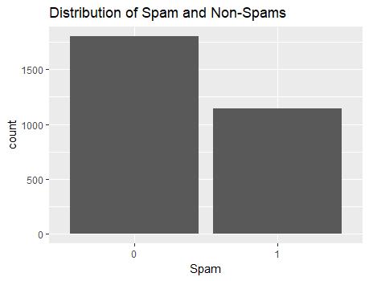

From the Bar Plot we can clearly see that the Number of E-mails which are not spam are clearly higher than the number of emails which are spams.

The Summary of some of the variables in the data set is as follows:

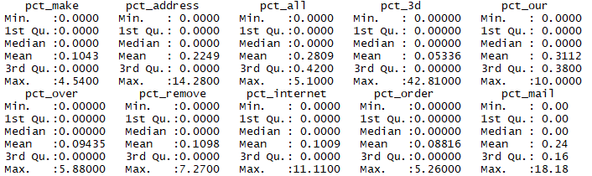

## Model Training

The data set is split into training and validation data sets. The training data set contains 80% of the observations and the rest 20% are in the validation data set.

### Logistic Regression

Since the problem is a Binary Classification problem so a natural choice for such a problem is a Logistic Regression Model.

The Logistic Regression model is fit using the “glm” in R.

The result for some of the significant variables is as follows:

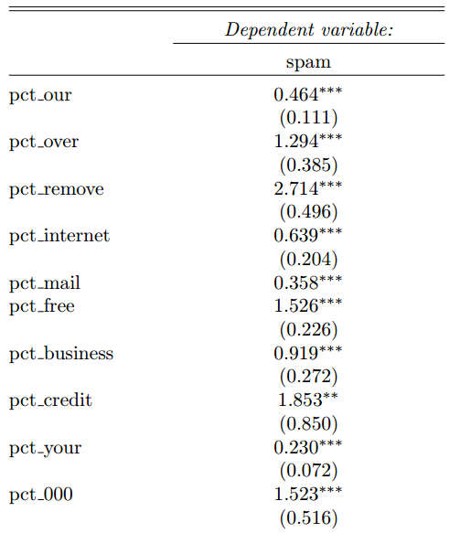

Next, a Backward stepwise Regression is run to remove unnecessary variables from the model. The criteria used for model selection is the AIC.

The Stepwise Regression leads to a Model:

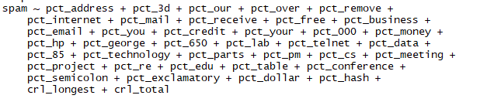The number of variables reduces to 39 from 57.

The Plot for the Deviance Residual is as follows:

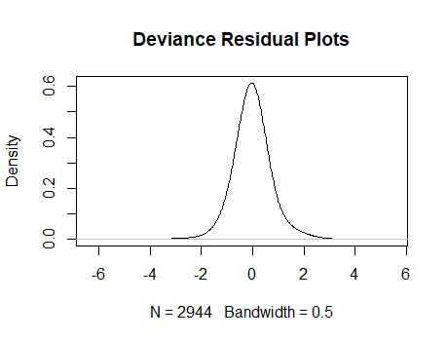

The Density plot is clearly Normal hence implying that the Model has been fitted well.

Next, the optimal cut-off point is calculated by maximizing the true positive and minimizing the false positive.

While calculating the cut-off point the cost for misclassification as given in the question has also been taken into consideration.

The Confusion Matrix hence achieved for the Validation data set is as follows:

|  |  |  |
| --- | --- | --- |
|  | Predicted | |
| Actual | 0 | 1 |
| 0 | 428 | 18 |
| 1 | 49 | 241 |

### Decision Tree

The Classification problem as specified above can also be solved using a decision tree.

A Decision Tree was fitted to the data set and the result obtained is as follows:

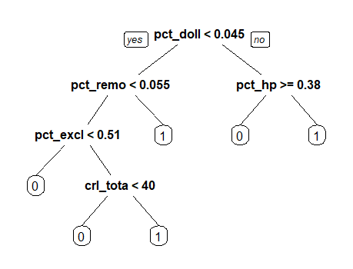

The Important Variables identified from the Decision tree are:

1. Percentage occurrence of “doll”
2. Percentage occurrence of “remo”
3. Percentage occurrence of “hp”
4. Percentage occurrence of “excl”
5. Total length of uninterrupted sequences of capital letters

The Confusion Matrix for the Validation data set is as follows:

|  |  |  |
| --- | --- | --- |
|  | Predicted | |
| Actual | 0 | 1 |
| 0 | 422 | 24 |
| 1 | 64 | 226 |

The ROC Curve for the two models is as follows:

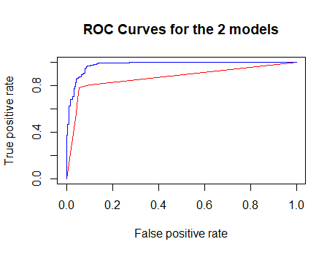

The Blue line refers to the Logistic Regression and the red refers to Decision Tree Model.

The Logistic regression model clearly has a higher Area under the Curve and is a better model. Thus, the Logistic regression model is used for generating predictions for the testing data set.